ASSIGNMENT NO.9: Data Retrieval, Functions, and Joins in MySQL

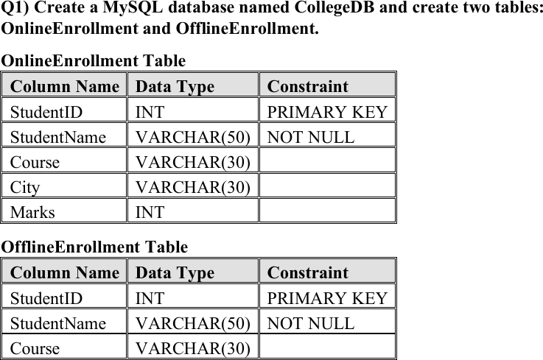

USE CollegeDB;

CREATE TABLE OnlineEnrollment ( StudentID INT PRIMARY KEY, StudentName VARCHAR(50) NOT NULL, Course VARCHAR(30),
City VARCHAR(30),
Marks INT
);

CREATE TABLE OfflineEnrollment ( StudentID INT PRIMARY KEY, StudentName VARCHAR(50) NOT NULL, Course VARCHAR(30),
City VARCHAR(30),

Marks INT
);

INSERT INTO OnlineEnrollment
(StudentID, StudentName, Course, City, Marks) VALUES
(1, 'Rahul Sharma', 'BSc IT', 'Mumbai', 78),
(2, 'Priya Patil', 'BCA', 'Pune', 85),
(3, 'Aman Verma', 'BSc CS', 'Nashik', 67),
(4, 'Sneha Joshi', 'BSc IT', 'Mumbai', 91),
(5, 'Karan Mehta', 'BCA', 'Thane', 74),
(6, 'Neha Shah', 'BSc IT', 'Pune', 88);

INSERT INTO OfflineEnrollment
(StudentID, StudentName, Course, City, Marks) VALUES
(4, 'Sneha Joshi', 'BSc IT', 'Mumbai', 91),
(5, 'Karan Mehta', 'BCA', 'Thane', 74),
(7, 'Rohan Desai', 'BSc CS', 'Mumbai', 69),
(8, 'Meera Kulkarni', 'BCA', 'Nashik', 82),
(9, 'Arjun Nair', 'BSc IT', 'Thane', 59),
(10, 'Divya More', 'BCA', 'Mumbai', 93);

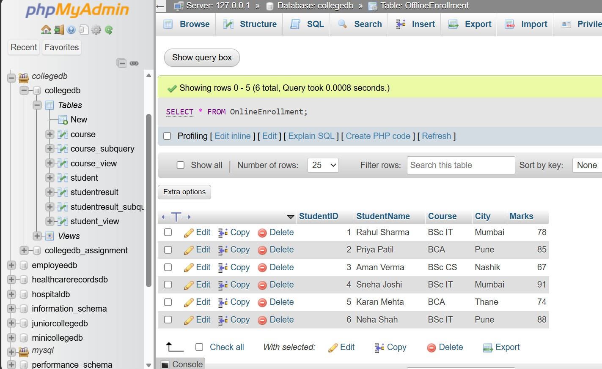
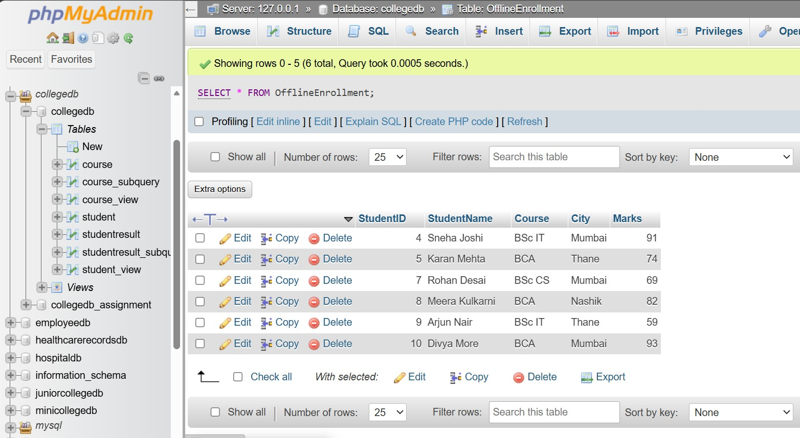



SELECT StudentID, StudentName, Course, City, Marks FROM OnlineEnrollment
UNION
SELECT StudentID, StudentName, Course, City, Marks FROM OfflineEnrollment;
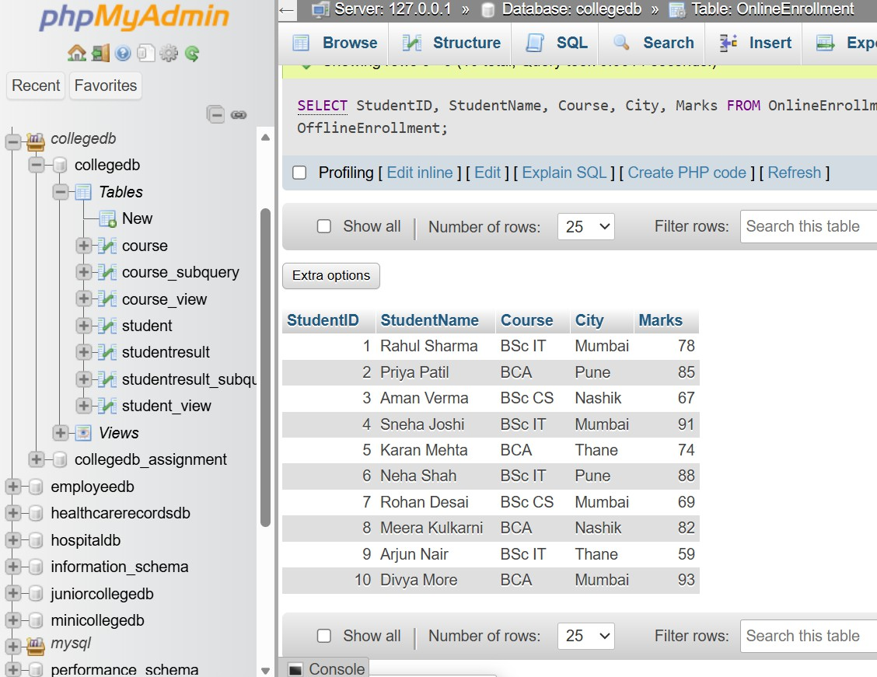

Q3) Write a MySQL query using UNION ALL to combine records from both tables while keeping duplicate records.

SELECT StudentID, StudentName, Course, City, Marks FROM OnlineEnrollment
UNION ALL
SELECT StudentID, StudentName, Course, City, Marks FROM OfflineEnrollment;

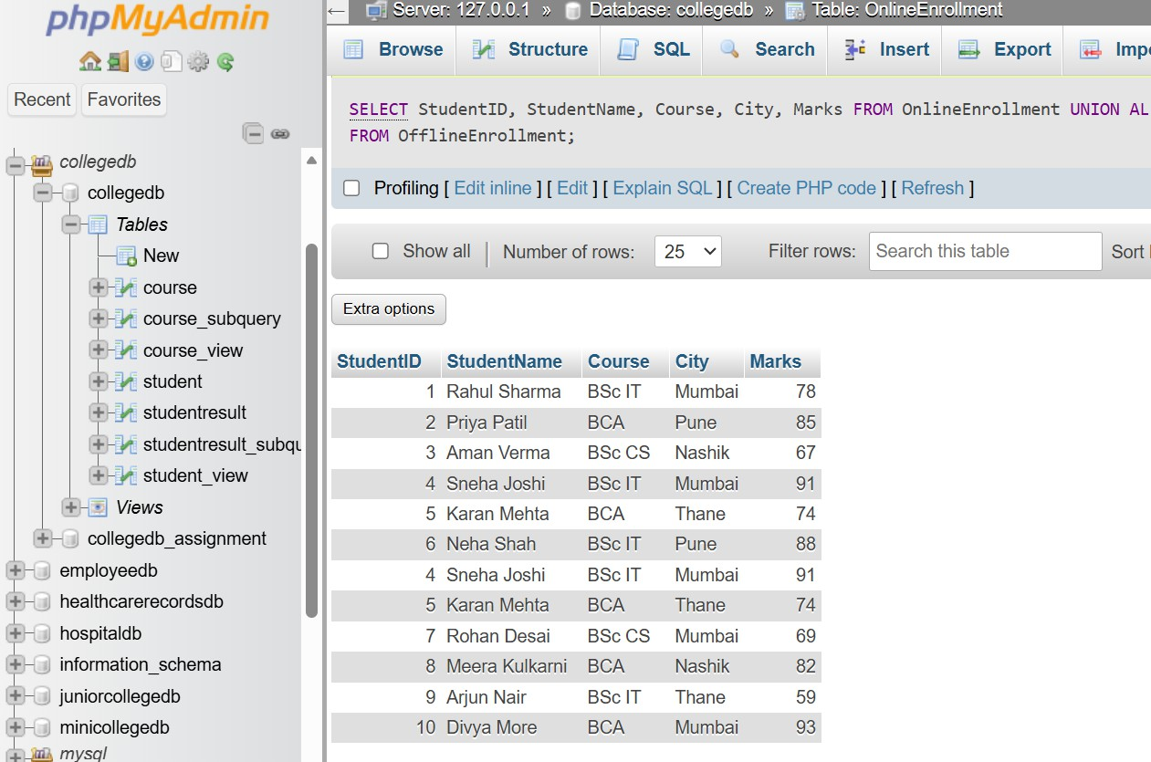

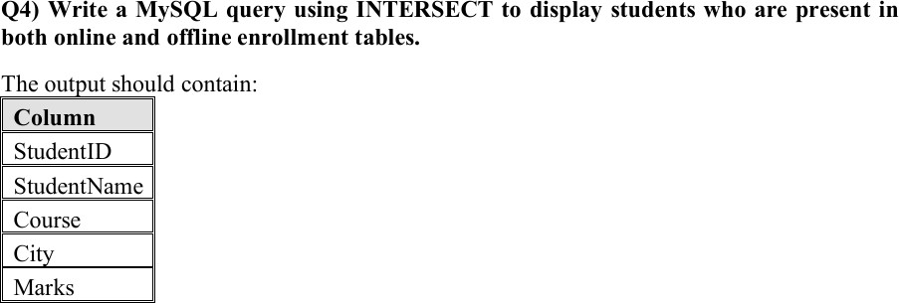

SELECT StudentID, StudentName, Course, City, Marks FROM OnlineEnrollment

INTERSECT

SELECT StudentID, StudentName, Course, City, Marks FROM OfflineEnrollment;

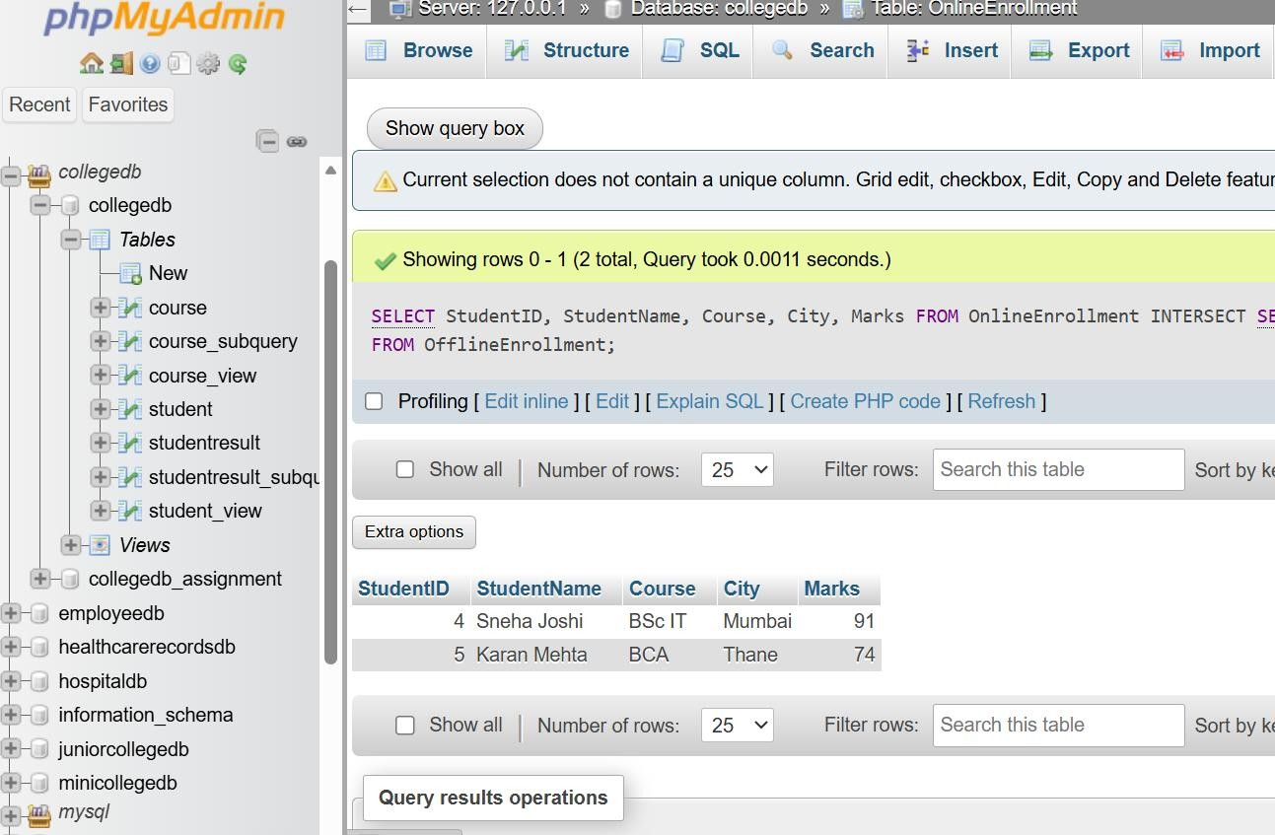

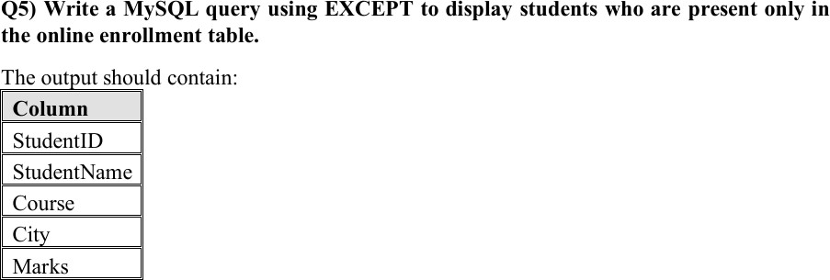

SELECT StudentID, StudentName, Course, City, Marks FROM OnlineEnrollment

EXCEPT

SELECT StudentID, StudentName, Course, City, Marks FROM OfflineEnrollment;
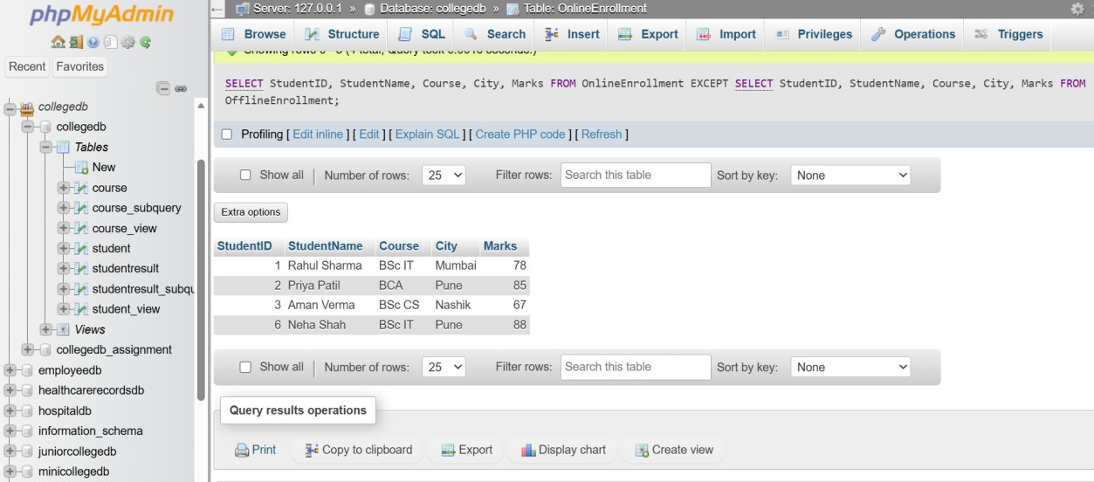

Q6) Write a MySQL query to display high-scoring students from both tables.

SELECT StudentID, StudentName, Course, Marks FROM OnlineEnrollment
WHERE Marks >= 85 UNION
SELECT StudentID, StudentName, Course, Marks FROM OfflineEnrollment
WHERE Marks >= 85 ORDER BY Marks DESC;



